CS 3600 Project 3 Wrapper
Devin Fromond Spring 2024
Due April 8th 2024 at 11:59pm EST via Canvas

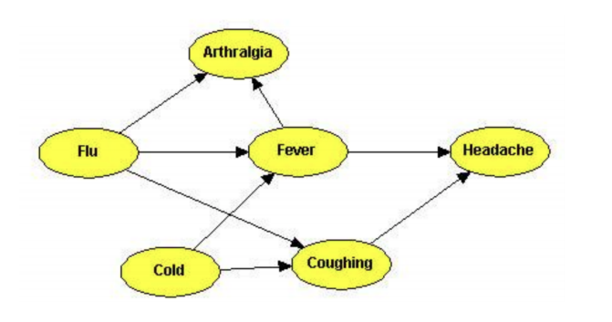
Introduction

Probabilistic inference over Bayesian networks is a standard AI technique for medical diagnosis. Bayesian networks represent complex causal relationships between patient information, medical conditions, and symptoms. Probabilistic inference allows us to compute diagnostic queries, determining the likelihood of medical conditions given observed symptoms as evidence. Use the example Bayes net above as a prompt for the following questions.

Question 1
Recall that the naive Bayes assumption is that no effects of a cause are also causes of each other. If two effects are correlated it is because they are related to the same, underlying cause. The naive Bayes model provides an alternative representation for diagnostic inference. Draw a Bayes net representing the naive Bayes model for diagnosing Flu given its symptoms (assume the symptoms of Flu are every successor of Flu in the Bayes net in Figure 1). Which model (the Bayes net in Figure 1 or the naive Bayes model that you’ve constructed) is a richer representation? That is to say, is there anything we can represent with one model that we cannot represent with the other model?
Answer:
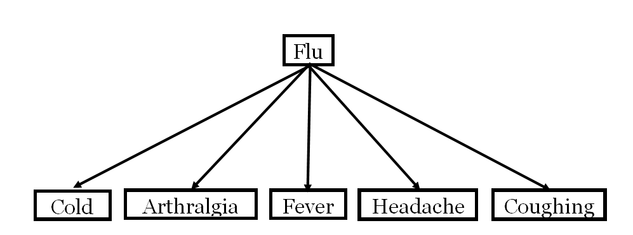
The Bayes network as outlined in Figure 1 is certainly the richer representation. The Naïve Bayes network merely demonstrates basic relationships and assumes future independence. The Bayes network, however, demonstrates relationships among variables – or symptoms – as well as the dependencies among them. The naïve Bayes network has a fixed size hypothesis space which – for more complex models and data – may underfit or overfit the data more than that of a Bayes Network. In layman’s terms, we know using the naïve model that the flu has relationships and is somehow connected to cold, arthralgia, fever, headache, and coughing. The specifics regarding the relationships and dependencies abstracted which greatly decreases the richness of the model. We are unable to effectively demonstrate these relationships and dependencies using the naïve network; we are only able to see view these relationships at the most general level. The Bayes network in Figure 1 demonstrates these relationships using bi-directional arrows – that is, the arrows are able to connect X to Y or Y to X, depending on the relationship. This allows for richer, more in-depth relationships to be observed as well as understand the cause-and-effect nature of these relationships.

Question 2
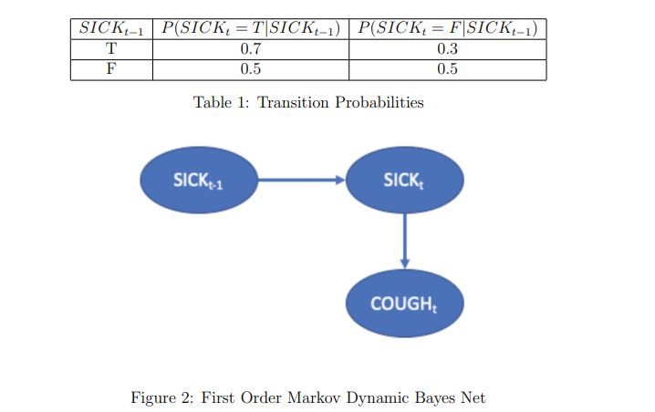
The traditional Dynamic Bayes Net has an unobservable random variable Xt that has a single parent of the value of Xt−1, which is the value of X at the previous time step. For example, SICKt is conditioned on SICKt−1. This can capture a relationship such as ”when one is sick, the probability is high that one is still sick at the next time step, and when one is not sick, one can become sick or stay well with equal probability”. See the image for an example. However, if one were to use this Bayes network to predict the future, the model may conclude that people become sick randomly and then stay sick. This setup does not account for second-order effects, such as: ”after one is sick for a while, the probability is high that one stops being sick”. A 2-Markov assumption states that an unobservable random variable Xt is conditioned on Xt−1 and Xt−2. Using a time step equal to a week, draw a 2-Markov Dynamic Bayes Network that captures the intuition that one can become sick at any time. When one is sick one is likely to remain sick unless they have been sick for two weeks, at which time they are likely to cease being sick. When one is sick, the probability of cough is high and when one is not sick, the probability of cough is low. Show all the conditional probability tables; make up reasonable numbers to express the relationships described above.
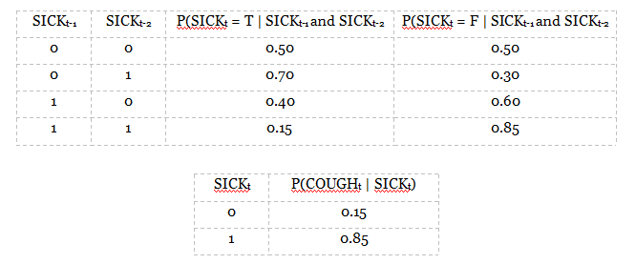
Answer:
Going through the table, we have if the past two weeks one has not been sick, then one can become sick or stay well with equal probability – following the intuition and probability in Table 1. If one has gotten sick within the past week, we will continue to follow the logic and probability as outlined in Table 1 and assume “when one is sick, the probability is high that one is still sick at the next time step…”. Continuing, when one was sick in the past two weeks – not the most recent week – we assume the probability of getting sick again is lower than that of not being sick the past two weeks. This follows a logical assumption that one has acquired antibodies or has built up some immunity but may still get sick. Finally, we observe if one has been sick the past two weeks that the probability of continuing to be sick is significantly lower than to cease being sick – as outlined in the question description. Furthermore, using the second table, we observe if one is sick, then the probability of a cough is significantly higher than if one were not to be sick – as is consistent with the phrasing of the question. The probability of a cough, if desired, could be integrated with the first table relatively simplistically using a function of P(SICK_{t} = T) and P(SICK_{t} = F). An approach to accomplish this could be as follows: P(COUGH_{t}) = P(SICK_{t} = T)(0.85) + P(SICK_{t} = F)(0.15).

